A Look at 2022: Takeaway Points from the *State of the Climate Supplement—E. Bartow-Gillies, J. Blunden, and T. Boyer*

Bartow-Gillies, Ellen, NOAA/NESDIS National Centers for Environmental Information, Asheville, North Carolina

Blunden, Jessica, NOAA/NESDIS National Centers for Environmental Information, Asheville, North Carolina

Boyer, Tim, NOAA/NESDIS National Centers for Environmental Information, Silver Spring, Maryland

Corresponding author: ellen.bartow-gillies@noaa.gov

*The following salient events and trends are reported in greater depth in the* State of the Climate in 2022*, the supplement to this issue of BAMS. Figures shown here are drawn from the supplement and are not cited in the text below.*

**GLOBAL CLIMATE**

The dominant greenhouse gases released into Earth’s atmosphere including carbon dioxide, methane, and nitrous oxide reached record highs in 2022. The annual global average carbon dioxide concentration at Earth’s surface for 2022 was 417.1 ± 0.1 ppm. This was 2.4 ppm greater than the 2021 amount, and was the highest in the modern atmospheric measurement record and in paleoclimate records dating back as far as 800,000 years. Annual growth in global mean carbon dioxide has quadrupled since the early 1960s. Throughout the year, the climate continued to respond to the ongoing increase in greenhouse gases and resulting warming.

With a global surface temperature that was between 0.25°C and 0.30°C above the 1991–2010 average, 2022 ranked as the fifth- or sixth-highest annual global temperature since records began in the mid to late 1800s. Even though the year ranked among the six warmest years on record, the presence of La Niña in the Pacific Ocean had a cooling effect on the 2022 global temperatures in comparison to years characterized by El Niño or neutral El Niño–Southern Oscillation (ENSO) conditions. Nonetheless, 2022 was the warmest La Niña year on record, surpassing the previous record set in 2021. All six major global temperature datasets used for analysis in the report agree that the last eight years (2015–22) were the eight-warmest on record. The annual global mean surface temperature has increased at an average rate of 0.08°C to 0.09°C per decade since 1880, and at a rate more than twice as high since 1981.

[INSERT Plate 2.1.a]

Overall, average annual precipitation totals were near to slightly below average over land and over oceans, while extreme precipitation was considerably above average in some regions and below average in others. The increase in global drought area that began in mid-2019 continued into 2022, and according to the self-calibrating Palmer Drought Severity Index, a new record for the amount of global land area experiencing moderate or worse drought conditions for any month (29%) was set in August 2022. In August, a new record was also set as 6.2% of the global land area experienced extreme drought conditions, the second most dire category. The global pattern of regional droughts in 2021 largely persisted through 2022, with the most extensive severe-to-extreme drought conditions prevailing over parts of South America, western North America, Europe, and the midlatitudes of Asia. A persistent lack of precipitation throughout much of Europe from winter to summer combined with warmer-than-usual conditions and a sequence of heatwaves triggered a severe-to-extreme drought which, at its peak, affected more than two-thirds of Europe and became one of the worst historical droughts in France, Spain, Germany, and Italy.

Arctic permafrost temperatures continued to reach record highs at many high-latitude and mountain locations. More frequent and intense heatwaves contributed to the second-greatest average mass balance loss for alpine glaciers across the globe since records began in 1970. Glaciers in the Swiss Alps lost a record 6% of their volume, and in South America, the combination of drought and heat left many central Andean glaciers snow free by mid-summer in early 2022. Exposed ice surfaces enhance surface darkening, which can lead to higher melt rates on alpine glaciers.

**GLOBAL OCEANS**

La Niña conditions in the equatorial Pacific Ocean that began in mid-2020, with a short break in 2021, continued into 2022. Three consecutive years of La Niña conditions resulted in an unusual “triple-dip” La Niña that had widespread effects on the ocean and climate in 2022. The mean annual global sea-surface temperature in 2022 equaled 2018 as sixth highest on record, but was lower than both 2019 and 2020 due in part to the long-lasting La Niña. Approximately 58% of the ocean surface experienced at least one marine heatwave, which is defined as sea-surface temperatures in the warmest 10 percent of all recorded data in a particular location for at least five days.

[INSERT Fig SB3.1a]

[INSERT Fig SB3.2 ]

Oceans store about 91% of the energy gained by Earth’s climate system over the last half century, and the global ocean heat content, measured in both the layers of the ocean’s surface to 700 meters depths and from 700 to 2000 meters depth, continued to increase and reached record highs in 2022. Annual average global mean sea level reached a new record high in 2022 at 101.2 mm above the level in 1993, the year in which satellite altimetry methods began. This reflects the annual upward trend of 3.4 mm ± 0.4 mm for this 29-year period. 2022 marks the 11th consecutive year where global mean sea level increased compared to the previous year.

**THE TROPICS**

In addition to La Niña conditions, the climate of the tropics was also affected by a strong negative Indian Ocean dipole event, which is a natural climate phenomenon that influences temperature and rainfall patterns around the Indian Ocean. This event, which developed in boreal spring, was one of the strongest negative events since 1982. It brought above-average temperatures and increased precipitation to the east Indian Ocean, and below-average temperatures and drier conditions to the west.

Globally, 85 named tropical cyclones were observed during the combined Northern Hemisphere and Southern Hemisphere storm seasons. This number was near the 1991–2020 average of 87 but below the 97 recorded in 2021. Across the globe, three tropical cyclones reached Category 5 intensity level on the Saffir Simpson Hurricane Wind Scale. Two, Super Typhoons Hinnamnor and Noru, were in the western Pacific, and the third was Major Hurricane Ian in the North Atlantic. This was the fewest Category 5 storms globally since 2017. The North Atlantic basin recorded 14 named storms in 2022, which is equal to the 1991–2020 average, but was also the fewest observed since 2015 and marked the end to a streak of six consecutive above-normal seasons in the basin. Other basins around the world also saw a near- or below-normal number of tropical cyclones. The western North Pacific had its third consecutive season with below-normal activity. Globally, the accumulated cyclone energy, which is an integrated metric of the strength, frequency, and duration of tropical storms, was the lowest on record since reliable records began in 1981.

[INSERT FigSB4.1]

**THE ARCTIC**

Average surface-air temperatures above the latitude 60°N continued to increase in 2022, which marked the ninth consecutive year that Arctic temperature anomalies were higher than the global mean anomalies. At 0.76°C above the 1991–2020 mean, 2022 Arctic surface-air temperatures were the fifth highest since records began in 1900. Seasonally, summer air temperatures were above normal across much of the Arctic. Summer also brought the most extensive wildfire season on record to southwest Alaska. Overall, the annual average Arctic precipitation for 2022 was the third-highest total since 1950, and three seasons (winter, summer, and autumn) ranked among the 10 wettest for their respective season. Since 1950, every season has shown an average increase in Arctic precipitation; in some regions this is experienced through heavier precipitation events, and in others through an increase in the number of consecutive wet days.

The area of ice measured during the September peak of melt season, known as the Arctic minimum sea-ice extent, was the 11th-smallest extent in the 44-year record. The 16 lowest September extents in the satellite record have all occurred in the last 16 years (2007–22).

In 2022, the amount of multiyear ice–ice that remains frozen during one or more melt seasons–remaining in the Arctic continued to be far lower than in the 1990s, indicating a trend that the Arctic has transitioned from a region dominated by multiyear ice to one dominated by first-year (seasonal) sea ice. While sea ice greater than four years old covered over 1 million km2 in September 2006, it covered only 127,000 km2 in September 2022. The Greenland Ice Sheet saw a record-breaking number of melt days at multiple sites in September, including one event at Summit Station more than 3200 meters above sea level, which has been observed only four other times in its 34-year observation history and never in September. Off the northwest coast of Greenland, in the Nares Strait, no sea-ice arch—a curve-shaped sea-ice edge spanning the Nares Strait—formed during 2022, which marks only the third time since the early 1980s that such an arch has not formed and is likely related to thinning sea ice in the Arctic.

[INSERT Fig 5.12]

**ANTARCTICA AND THE SOUTHERN OCEAN**

Many major climate themes over Antarctica and the surrounding Southern Ocean in 2022 continued on and intensified from 2021. For most of 2022, a deep Amundsen Sea Low occupied the Bellingshausen, Amundsen, and Ross Seas, and a strong blocking high persisted in the far southwest Pacific, both of which contributed to another warm year in Antarctica. An unusually high number of landfalling atmospheric rivers—long, narrow regions in the atmosphere that transport water vapor outside of the tropics and release rain or snow upon landfall—brought heavy snowfall to Antarctica. This, combined with the aforementioned features and higher rates of snowfall accumulation compared to loss, resulted in record highs in net annual Antarctic surface mass balance, which is the difference between the precipitation (primarily snow and ice) that has accumulated on the upper surfaces of glaciers and ice sheets, and what has been lost due to melt, runoff, or evaporation. Since the start of satellite-derived ice-sheet mass balance measurements (1993), 2022 marked the first time in which a positive net mass balance was observed in Antarctica.

Persistent northerly flow, especially across the Bellingshausen/Weddell Seas and the southeast Indian Ocean, enhanced sea-ice melt during the 2021/22 retreat season, impeded sea-ice growth during the advance phase, and led to early and rapid sea-ice retreat beginning in late September. More than 100 days of record-low sea-ice extent, which is the total region with at least 15 percent sea ice cover, and sea-ice area, the total region covered by ice, were observed in 2022. In February, two new all-time annual record lows in net sea-ice extent and area were observed.

Warm conditions on the eastern Peninsula produced anomalously high surface melt across the Larsen Ice Shelf during the 2021/22 summer, ending with a record-breaking heat wave and melt event on the Peninsula in February 2022. It was the second-warmest year on record for all five of the long-term staffed weather stations located on the Antarctic Peninsula. While four months observed record-low monthly-averaged values of sea-ice extent, six months saw record-low monthly values of sea-ice area.

The 2022 Antarctic ozone hole was slightly larger than average and ranked 18th largest in 43 years of satellite observations. The ozone hole closed six days later than average in 2022, due to weaker-than-average planetary wave activity from September through early November. Following a similar seasonal development seen in the last two years, the 2022 ozone hole had a slower-than-average growth rate that is consistent with ozone recovery due to the Montreal Protocol.

[INSERT Fig SB6.1]

**REGIONAL CLIMATES**

*North America*

Canada, the contiguous United States, and Mexico each had a top-20 warmest year on record. Canada, which had its 16th-warmest year on record, experienced summer and autumn temperatures among their six warmest such periods in the 75-year record. Four Canadian provinces had average annual temperatures that ranked among their 10 warmest on record. Temperatures across the continental United States have increased at a rate of 0.27°C per decade since 1970. In 2022, the contiguous U.S. equaled 1953 for its 18th-warmest year in the 128-year record. Mexico had its eighth-warmest year since records began in 1950. Annual precipitation was near average across Mexico and the United States, although regional anomalies varied widely across both countries.

Across much of the western United States, drought persisted for a majority of the year with only some improvement resulting from the summer monsoon in the Southwest. For the third consecutive year, drought coverage across the contiguous United States remained significant, ranging from a minimum extent of 44% in September to a maximum extent of 63% in late October. This marks the largest drought footprint in the contiguous U.S. since 2012. With sunny skies, low humidity, and windy conditions across much of the central and western United States, low precipitation combined with high temperatures led to the rapid intensification and expansion of drought throughout the year. This phenomenon, also known as “flash drought”, rapidly reduced soil moisture throughout the Plains to the Lower and Mid-Mississippi Valley during the summer and early autumn. The multi-year drought resulted in water stress and shortages in many locations across the western United States as some major reservoirs dropped to their lowest levels on record. During the first half of the year in Mexico, severe-to-exceptional drought prevailed throughout most of northern Mexico, which encouraged the spread of wildfires. By the end of the year, forest fires had burned 39,626 hectares, which marks the second-largest area burned by forest fires since records began in 1998.

[INSERT Fig 7.5]

*Central America and the Caribbean*

Across Central America, most stations recorded near-average annual temperatures for 2022. Only two stations, one in Panama and one in Costa Rica, had significantly below-average annual temperatures. Meanwhile, the Caribbean experienced its eighth-warmest year since records began in 1950. Annual temperatures in the Caribbean region have been increasing at a rate of 0.17°C per decade since 1970. In The Bahamas, the city of Freeport recorded its warmest year on record.

Although most stations across the region recorded near-average annual rainfall totals, heavy rains plagued the region for much of the year. Consistent with the typical pattern of the cold phase of El Niño–Southern Oscillation (La Niña), most stations along the Pacific coast had above-average yearly accumulations. Several tropical cyclones also impacted the area in 2022. Tropical Storm Bonnie brought flooding and landslides to Costa Rica, Nicaragua, and El Salvador in early July. Hurricane Fiona made landfall in Puerto Rico on 18 September, resulting in widespread flooding and loss of power across the entire island that affected over one million people. Later in September, Hurricane Ian brought landslides and flooding to Jamaica as a tropical storm before making landfall in western Cuba as a Category 3 hurricane. Hurricane Julia made landfall in Nicaragua on 9 October and affected approximately 7500 people, flooded homes and infrastructure, and overflowed dozens of rivers before causing more damage in Guatemala, El Salvador, and Panama. On 9 November, Hurricane Nicole brought coastal flooding to Grand Bahama Island.

*South America*

Although most of southern South America recorded annual mean temperatures that were near to below average, heatwaves affected much of the region during the austral summer and led to multiple new historical maximum temperature records. Northeastern Argentina saw the highest positive anomalies, with some reaching 3°C above average. Argentina had its third-warmest summer on record. The heatwave was not limited to Argentina; Florida City, Uruguay, recorded a maximum temperature of 44.0°C on 14 January, the highest value for this location since 1991. Uruguay’s Artigas department recorded its warmest summer since 1991. Despite this summer heat, Uruguay and Chile each had a cooler-than-average year.

Warm sea-surface temperatures across the Caribbean combined with La Niña conditions in the Pacific created favorable conditions for above-average precipitation across northern South America. Abundant rainfall in the central and northern Amazon as well as drought in the southern Amazon and Parana-La Plata basin were also associated with the ongoing La Niña. Heavy rainfall affected parts of Brazil during January and again in May. By the end of May, the Rio Negro at Manaus reached its third-highest water level in the 119-year record due to prolonged heavy rainfall. Across the Amazonas state, flooding affected over 306,000 people and prompted 35 municipalities to declare a state of emergency. In October, Hurricane Julia brought heavy rainfall to areas of Venezuela and Colombia that were already saturated from above-average September rainfall; mud and debris inundated the city of Las Tejerías in Venezuela, resulting in 56 fatalities, 10,000 resident evacuations, and the destruction of almost 800 homes where economic losses totaled $500 million U.S. dollars.

Drought conditions plagued much of Argentina, Chile, and parts of Uruguay for most of the year; in some areas, precipitation totals were up to 60% below average. In south-central Chile, the “Mega Drought” continued into its 13th consecutive year, and marked the third consecutive year of rainfall deficit in most of the region. In southern Chile, Punta Arenas had its second-driest year since 1966. Seven locations in Argentina recorded their driest years on record. Consistent with typical La Niña patterns, parts of Bolivia and Peru also experienced drought conditions for much of the year. Several locations in Bolivia were record dry, with more than 160 municipalities and 247,000 hectares affected. The southern Andes region in Peru recorded its worst drought conditions since 1965, with rainfall ranging from none to 40% of normal.

*Africa*

In 2022, annual mean temperatures over much of Africa were above average. North Africa suffered from heat waves throughout most of the boreal summer, with temperatures exceeding 2°C above normal across parts of the region. Smara, Morocco, observed a record-high maximum temperature of 49.1°C during the summer. South Africa had its fourth-warmest year on record. Although most of Central Africa recorded near-average temperatures, areas just north of the Mbang Mountains in Cameroon experienced one of their coldest Mays on record with temperatures more than 2°C below average. Southern Africa had its coldest August on record, with minimum temperatures as much as 5°C below normal over Angola, western Zambia, and northern Namibia.

Much of Africa experienced devastating rainfall and flooding events in 2022. In West Africa, consistent above-average rainfall and heavy rain events led to widespread flooding across the region during the boreal summer. From June to October, heavy rainfall triggered destructive flooding in 19 of Chad’s 23 provinces, affecting more than a million people through displacement, injury, infrastructure damage, and heightened malnutrition risk. Flooding in the region also affected more than 150,000 people in northern Cameroon. Réunion, in the West Indian Ocean saw 116% of its normal annual rainfall; its rainy season ranked fifth wettest on record.

Meanwhile, equatorial eastern Africa experienced its fifth consecutive failed rainy season by the end of 2022. The annual total rainfall was lowest on record since 1991 across some areas. According to the U.S. Agency for International Development, this ongoing 2.5-year drought is the most extensive and persistent drought event in decades and has led to crop failure, millions of livestock deaths, water scarcity, and inflated prices for staple food items. In Tunisia in northern Africa, October and December were the driest on record for their respective months.

In late January, Tropical Storm Ana brought floods and landslides to Madagascar, Malawi, and Mozambique. Cyclone Batsirai made an early February landfall on the eastern coast of Madagascar, and its impacts were the most violent in the region for more than 25 years. Cyclone Gombe made landfall in Mozambique in mid-March, triggering floods across the country that affected more than 736,000 people. More than 230 fatalities were reported from these storms.

*Europe and the Middle East*

Europe had a year that ranked between its second and fourth warmest on record, with an annual temperature 0.7°C to 1.0°C above the 1991–2020 average depending on the dataset used for analysis. All European countries reported above-normal annual temperatures. Sixteen countries (Spain, Portugal, Belgium, France, the United Kingdom, Ireland, Germany, Switzerland, Hungary, Italy, Luxembourg, Croatia, Monaco, Montenegro, Slovenia, and Bosnia and Herzegovina) reported their warmest years on record. Six more European countries recorded an annual temperature among their four highest. All seasons were warmer than normal across the continent; summer was exceptionally warm, with anomalies ranging from +2.0°C and +3.0°C. Eleven countries reported a summer that ranked among their three warmest on record. On the Iberian Peninsula, a nine-day heatwave in June became the longest heatwave with the largest affected area since 2003. Warm air from Spain then advanced into central Europe, where two stations in Germany and a station each in Switzerland, Austria, Czechia, and Hungary set all-time record-high temperatures in mid-June.

Exceptional summer heat continued into July. Multiple temperature records were broken throughout Spain and Portugal in early July; two municipalities in Portugal recorded temperatures greater than 40°C for 10 consecutive days. This extreme heat contributed to more than 1000 fatalities in the region. A 14-day heatwave swept through western Europe, and on 18 July, 104 stations in France broke their all-time records. This was the fifth-longest and third most intense heatwave in France since 1947. Monthly station records also broke in Ireland on the same day. One day later, England recorded a temperature of 40°C for the first time ever, and more than 100 stations recorded new local maximum temperatures. Stations in The Netherlands, Germany, Switzerland, and Slovakia also set new all-time temperature records associated with the heatwave. Even Scandinavia did not escape the heat; on 21 July, a station in southeastern Sweden reported its highest temperature on record in the country since 1947. Yet another heatwave hit Europe in early August, causing several stations in Germany and Switzerland to set more record-high local monthly and all-time temperatures.

A relatively intense Azores high, combined with dry air advection from northwest Africa, led to drier-than-average winter conditions for nearly all of the Iberian Peninsula and the Middle East. Although spring was drier than normal across most of Europe, above-average precipitation fell across Belarus, European Russia, and most of the Iberian Peninsula, which ended its winter drought. However, dry conditions soon returned. High summer temperatures in Europe were accompanied by unusually dry conditions, with most of Europe receiving between 50% and 90% of normal summer precipitation. Summer 2022 was the driest summer on record for Belgium and Luxembourg, and the second driest for Croatia. Along with unusually high temperatures, Portugal and Spain also recorded very dry summers. Multiple large wildfires broke out across central Portugal and central western Spain, prompting Portugal to declare a state of emergency from 11 to 15 July. Slightly higher-than-average autumn precipitation brought relief to some parts of western Europe, but many areas across the continent recorded near- to below-average autumn precipitation.

While most countries in the Middle East recorded near-average annual temperatures in 2022, northeastern Syria and eastern Jordan saw anomalies up to +1.0°C above average. Generally drier-than-average conditions prevailed in most of the region, with Syria, Lebanon, and northern parts of Israel receiving less than 80% of their normal precipitation. Similar patterns were observed in Türkiye and the South Caucasus region, where some areas in Türkiye received as little as 60% to 80% of normal precipitation, and Armenia recorded its fourth-driest year since 1935. Early in the year, Israel recorded its third-rainiest January with 120% to 160% its normal precipitation. A storm brought snow to the mountains of Israel in late January, and Jerusalem recorded its largest snowfall since 2015.

*Asia*

Annual mean temperatures were above normal across much of Asia and Siberia in 2022. China recorded its second-warmest year since records began in 1951, while Hong Kong observed its sixth-warmest year since the start of its records in 1884. South Korea, Singapore, and Indonesia had years that ranked 9th, 10th (equal with 2021), and 13th warmest, respectively, on record. South Asia did not escape the heat either; India had its fifth-warmest year on record since 1901. Russia was also unusually warm, with an annual average temperature that ranked fifth highest on record. On the other hand, Vietnam’s annual mean temperature—though still +0.4°C above average**—**was the lowest on record since 2015.

Large areas of northwest India and Pakistan experienced prolonged heat waves in March and April, marking an early onset of the hot weather season. India recorded its hottest March and broke monthly temperature records throughout both months. Many stations in Pakistan recorded all-time highs in March and April. This heatwave triggered forest fires in India, reduced crop yields across India and Pakistan, and was associated with at least 90 fatalities. From mid-June to late August, a heatwave hit east-Central China and lasted for 79 days, making it the longest heatwave to hit China since 1961. The Sichuan basin, Jianghuai, Jianghan, and Jiangnan all reported temperatures above 35°C for periods that ranged from 30 to 65 days, and 361 stations recorded all-time high temperatures. In western Japan, summer temperatures equaled those in 2013 and 2018 as the highest on record. From late June to early July, South Korea observed its highest mean temperature since 1973. Summer heat did not escape Russia, which reported its third-warmest summer on record.

Record-breaking summer heat in central and eastern Asia, particularly in the Yangtze River basin, led to a devastating drought that affected more than 38 million people and caused a direct economic loss of $4.75 billion (U.S. dollars). Iran had its second-driest year on record; between regional droughts and summer flash floods, the country saw nearly $7 billion (U.S. dollars) in damage to crop yields and rural areas. Meanwhile, sustained summer monsoon rainfall led to devastating flooding in Pakistan from June through August. Pakistan received around three times its normal amount of monsoon precipitation in August, with some regions receiving up to eight times their expected monthly totals. Resulting floods affected over 30 million people, caused over 1700 fatalities, led to billions of dollars of crop and property losses, and was recorded as one of the world’s costliest natural disasters of all time. Heavy rainfall also affected Afghanistan from May to August, where associated flooding caused infrastructure damage and fatalities.

[INSERT Fig SB7.3]

*Oceania*

For the third consecutive year, La Niña affected most of Oceania. As is expected with La Niña years, drier conditions prevailed for some equatorial southwest Pacific islands, while Australia saw generally wetter conditions with some flooding across broad areas of the continent. Typhoon activity in Micronesia was relatively quiet for the year, which is also typical of La Niña conditions. Several large-scale climate patterns, including a negative Indian Ocean dipole during austral winter and spring, positive Southern Annular Mode conditions, and La Niña all contributed to Australia’s second-wettest spring in the 123-year record. Overall, 2022 was Australia’s ninth-wettest year on record. New Zealand also had an unusually wet year, as 2022 was its eighth wettest on record. The South Pacific Convergence Zone was located south of its climatologically normal position during January to March, resulting in several stations in Fiji, Vanuatu, Niue, and Tonga reporting rainfall totals above the 90th percentile.

Temperatures varied across the region. Although Australia recorded an annual temperature 0.13°C below average, it was the 22nd-warmest year in Australia's 113-year record. Despite relatively cool years in 2021 and 2022 due to recurrent La Niña and high rainfall amounts, the decade 2013 to 2022 ranked as the warmest 10-year period on record for Australia. While La Niña years generally lead to lower temperatures in Australia, La Niña is typically linked with higher air and sea temperatures in New Zealand. This proved true in 2022, which surpassed 2021 to mark New Zealand’s warmest year on record. Across the country, 47 stations recorded their warmest year on record and 33 more recorded annual average temperatures that ranked among their four highest on record. In the Bay of Plenty, New Zealand’s longest continuous marine heatwave was recorded.

[INSERT Fig 7.60]

Tropical Cyclone Dovi, which formed in February, was the most powerful tropical cyclone to impact the South Pacific in 2022. Dovi brought heavy rainfall and flooding to Vanuatu, where it led to overflowing rivers and housing and crop destruction before bringing more flooding and landslides to southern New Caledonia. As Dovi weakened, it brought strong winds and heavy rainfall to Norfolk Island and northern New Zealand. Dovi caused a total of $80 million (U.S. dollars) to the regions it affected. In late February through early March, extreme multi-day rainfall resulted in record-breaking floods across southeast Queensland and eastern New South Wales in Australia. Parts of southeast Queensland observed their highest flood peaks since 1893, and parts of northeast New South Wales saw peak flood levels surpass previous observations.

2022 Global Surface Temperature Anomalies

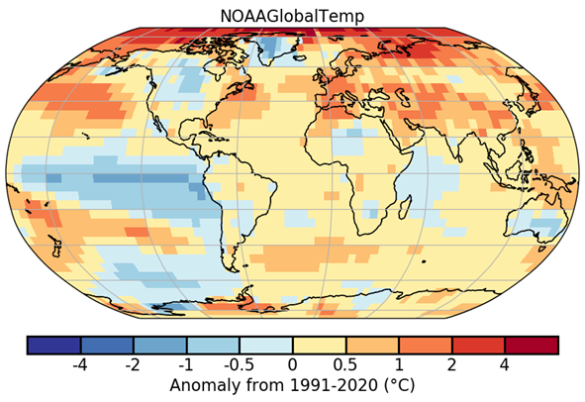

Caption: During 2022, warmer-than-average conditions were present across most of the world’s land and ocean surfaces, shown here in the NOAAGlobalTemp surface air temperature annual anomaly map (°C, relative to the 1991–2020 base period) as areas shaded from orange to red. Limited areas (parts of northern North America, South America, Africa, Australia, and the southeastern, central, and eastern tropical Pacific Ocean) experienced near- to cooler-than-average conditions (blue shading). (Plate 2.1.a in State of the Climate in 2022; see discussion in section 2.b)

The first “triple-drip” La Niña of the twenty-first century

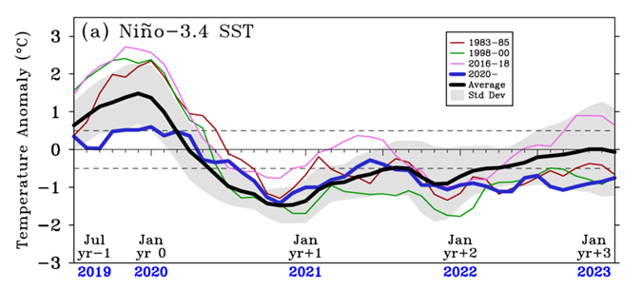

Caption: As the tropical Pacific experienced a third consecutive year of below-average sea-surface temperatures, 2020–22 marked the first “triple-drip” La Niña of the twenty-first century. Although La Niñas in three consecutive years are rare, similar events occurred in 1998–2001 and 1973–76. Extended La Niña events can have prolonged impacts of weather variability patterns across the globe; for example, in the 2020–22 La Niña, Australia saw excessive rainfall, the Horn of Africa experienced severe and extensive droughts, and parts of the western United States struggled with exceptional drought. Monthly sea-surface temperature anomalies from July 2019 to January 2023 (blue line) in the Niño-3.4 index region (5°S–5°N, 120°W–170°W) are plotted here. (Fig SB3.1a in State of the Climate in 2022; see discussion in sidebar 3.1.)

The effects of El Niño–Southern Oscillation on global mean surface temperature

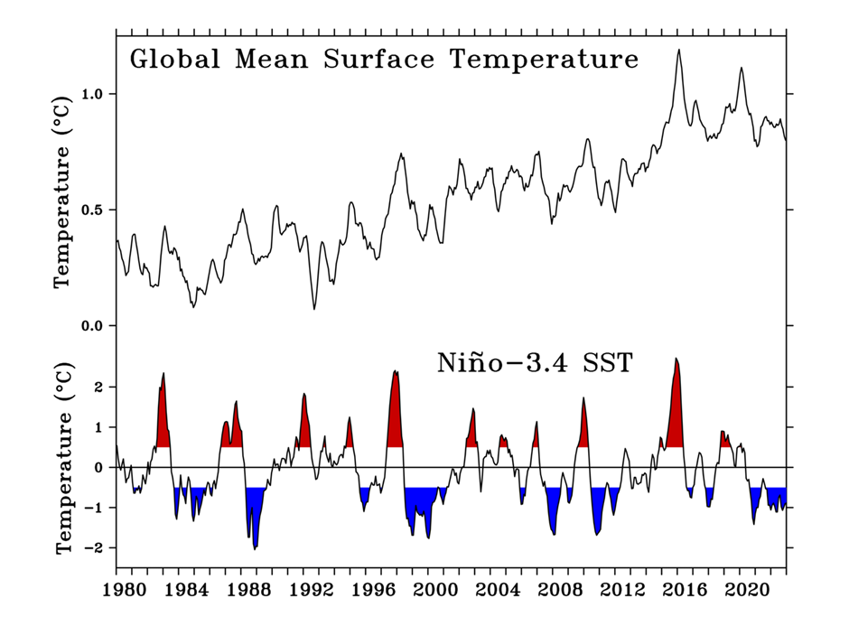

Caption: Global mean surface air temperature over the last eight years (2015–22) has been the highest on record. Although carbon dioxide concentrations in the atmosphere are currently highest on record in 2022, the highest annual temperature on record occurred in 2016 during a strong El Niño event. Year-to-year temperature variations are influenced by the state of ENSO, which redistributes heat on a planetary scale. For every 1°C of El Niño (periods in red) warming in the Niño-3.4 region, the global surface temperature rises by 0.073°C±0.024°C (with 95% confidence) with a delay of three months, and a 1°C cooling in the Niño-3.4 region during La Niña (periods in blue) results in a comparable drop in global mean surface air temperature. As a result, unusually cold La Niña conditions since the end of the 2015/16 El Niño have temporarily halted the rise in global temperatures despite increasing greenhouse gas concentrations. (Fig SB3.2 in State of the Climate in 2022; see discussion in sidebar 3.1.)

Hurricane Fiona, the most intense cyclone in Atlantic Canada’s history

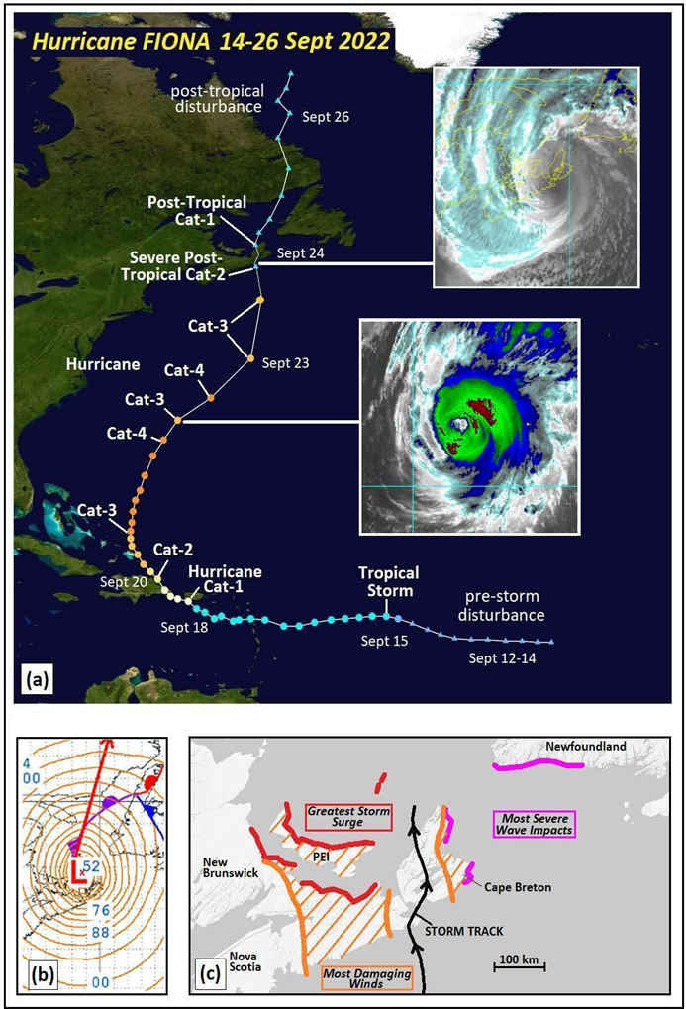

Caption: Hurricane Fiona, which developed from a tropical wave off the coast of Africa, reached hurricane status as it approached Puerto Rico, where it caused heavy flooding and severe power outages. The storm reached its peak intensity as a Category 4 storm as it tracked just northwest of Bermuda before later making landfall in eastern Nova Scotia as a Category 2-force severe post-tropical cyclone with the lowest sea-level pressure of any cyclone recorded over land in Canada. Fiona’s track at 6-hr intervals with select milestones labeled can be seen in (a), where triangles denote pre- and post-tropical phases. Sea-level pressure can be seen in (b), with select contour labels marked, and (c) highlighted regions in Atlantic Canada with the most significant storm impacts. Fiona was the most intense and most destructive tropical or post-tropical cyclone in Atlantic Canada’s history. (Fig SB4.1 in State of the Climate in 2022; see discussion in sidebar 4.1)

Younger sea ice now comprises most of the Arctic

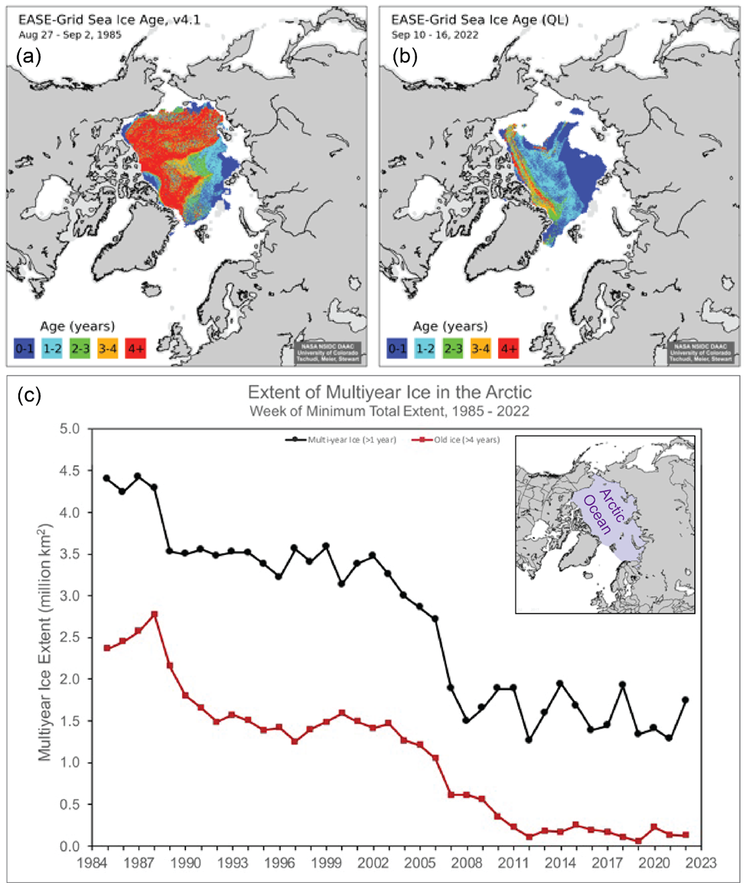

Caption: One week before the 2022 annual minimum extent, when the age values of remaining sea ice are incremented to one year older, the amount of multiyear ice remaining in the Arctic was almost half its value from the 1990s. In 1985 (a) older (more than two years old) ice dominated the Arctic according to EASE-Grid sea ice age records, whereas in 2022 (b), younger sea ice (less than two years old) dominated the region. In September 2006, sea ice more than four years old covered nearly eight times more area than in September 2022. Since 2012, the Arctic has been nearly devoid of the oldest ice. A younger ice cover implies a thinner ice pack that is more sensitive to atmospheric and oceanic conditions. (Fig 5.12 in State of the Climate in 2022; see section 5e for discussion.)

Unusual heat hit East Antarctica during its transition to winter

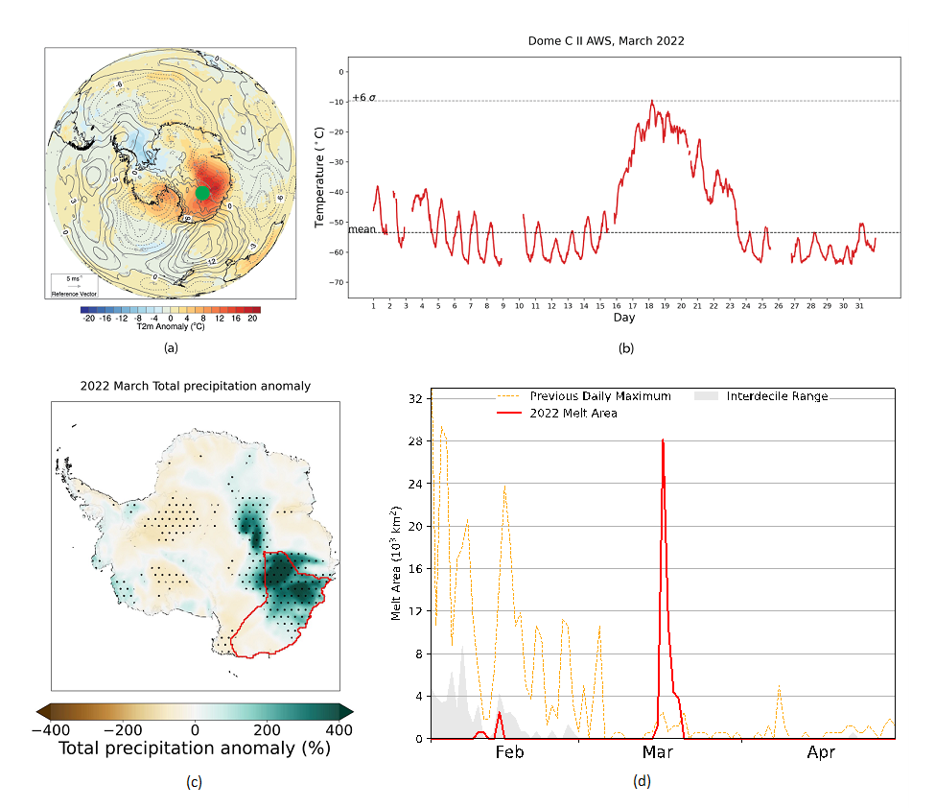

Caption: Although March historically marks the transition to Antarctic winter, an unprecedented “heatwave” associated with an intense atmospheric river hit East Antarctica on 17–18 March. Darker shades of red in (a) showcase the unusual heat as mean 2-m temperature anomalies (°C) for 14–20 March 2022 as compared to the 1991–2020 March mean. In another dataset of 10-min quality-controlled temperature observations (°C) from the UW-Madison Dome C II automated weather station, the abnormal heat (b) is shown as the red line (March 2022 temperature) relative to the black horizontal dashed line that represents the Dome C II March climatological-mean temperature. A new all-time record-high temperature (-9.4°C) that was 44°C above the March average was set on 18 March at Dome C. The heatwave event was followed by the collapse of the critically-unstable Conger Ice Shelf, and the unusual heat was later entrained into a subsequent low-pressure system off the Amery Ice Shelf on 21 March where it was associated with reduced sea-ice extent. Although events such as these are generally short-lived and unprecedented, intense phenomena are more likely to occur in future climate scenarios. (Fig. SB6.1 in State of the Climate in 2022; see discussion in sidebar 6.1)

The United States recorded 18 billion-dollar weather and climate disasters in 2022

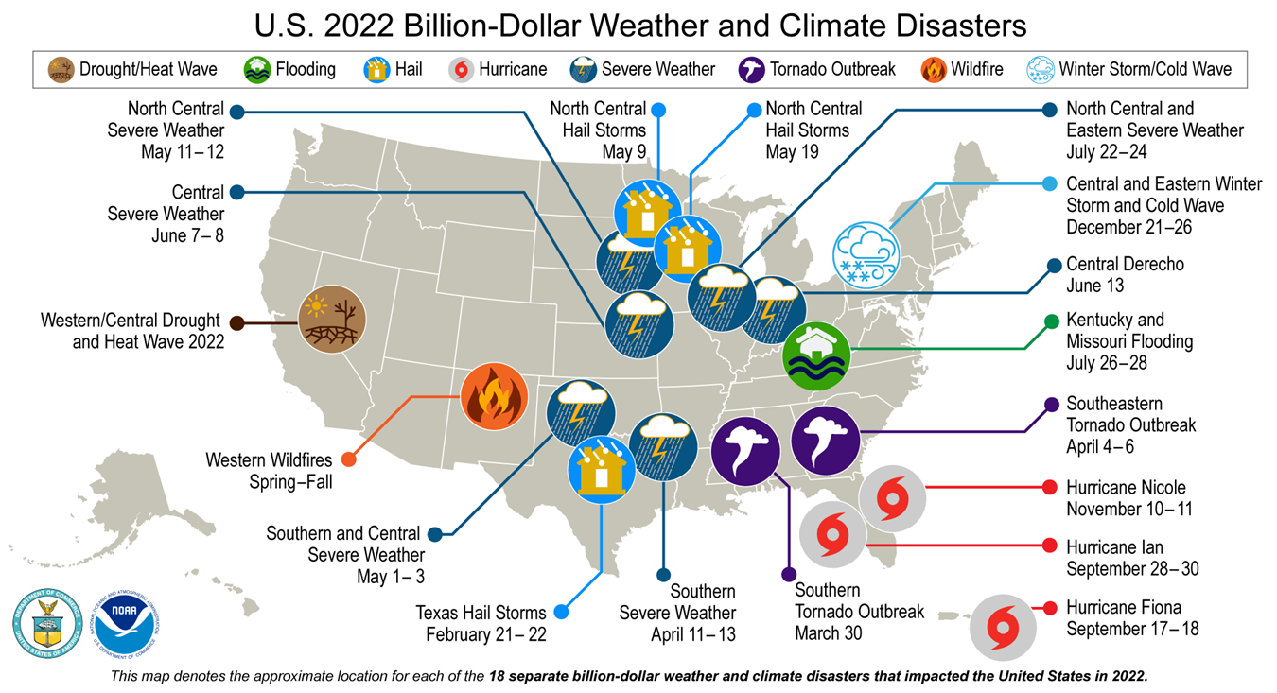

Caption: In 2022, the United States experienced 18 weather and climate events with losses each exceeding $1 billion (U.S. dollars). These events included six severe storms, three tropical cyclones, three hail events, two tornado events and one each for flood, drought, winter storm, and wildfire events. In total, U.S. disaster costs for 2022 exceeded $165 billion (U.S. dollars), which marked the third-highest cost on record. Hurricane Ian, at $113 billion (U.S. dollars), was the costliest event of 2022 and the third-costliest hurricane on record since 1980. (Fig 7.5 in State of the Climate in 2022; see discussion in section 7b2.)

Heat in the Yangtze River Basin

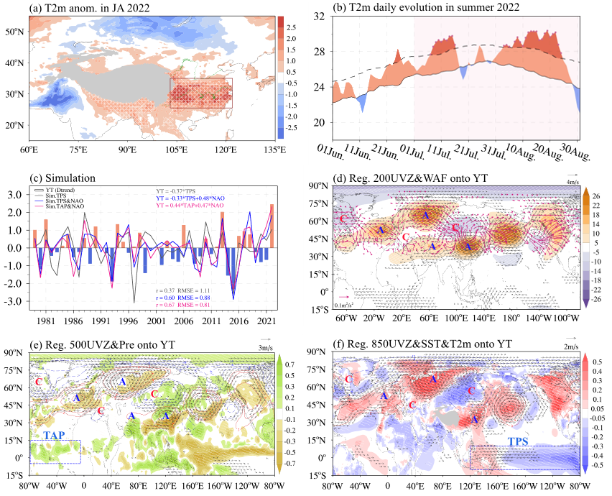

Caption: Unusually high temperatures in the Yangtze River Basin led to serious hydrological drought, agricultural failure, and ecological damage totaling $4.75 billion (U.S. dollars). The largest temperature anomalies in the area were recorded in July and August 2022. In (a), temperature anomalies measured at 2 meters above the ground (shading, °C) are shown for July and August, and extreme high temperature days (relative to the 90th percentile of temperature records from 1991–2020) during those two months are displayed as slashed regions. The daily evolution of temperatures averaged in the Yangtze River basin from June to August are shown in (b), where the dashed curve represents the top 10% of the temperature records and the solid line shows the average for the period 1991-2020. (Fig SB7.3 in State of the Climate in 2022; see discussion in sidebar 7.42.)

The phase of the El-Niño–Southern Oscillation contributes to sea levels across the western Pacific tropics.

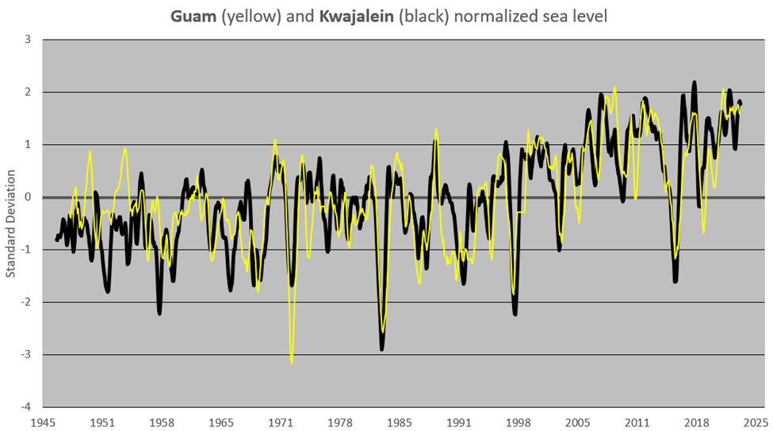

Caption: La Niña is typically associated with higher-than-average sea levels across the western Pacific tropics. By the boreal summer of 2022, sea-level heights throughout Micronesia were near their historical peaks. A time series of the sea levels from Guam and Kwajalein, two widely separated stations, illustrate the strength of the coherence of the regional sea level and the historical perspective of the high stands during 2022. At Guam, 2022 marked the fourth-highest stand in the historical record. Since 1998, the tropics of the western North Pacific has experienced the largest magnitude of sea-level rise across the globe in combination with long-term climate change. Three major short-term dips can be seen during the 2002, 2015, and 2018 El Niño events, and absolute historical high stands during 2010–2012 and 2020–2022 occur with La Niña periods. (Fig. 7.60 in State of the Climate in 2022; see discussion in section 7h.)